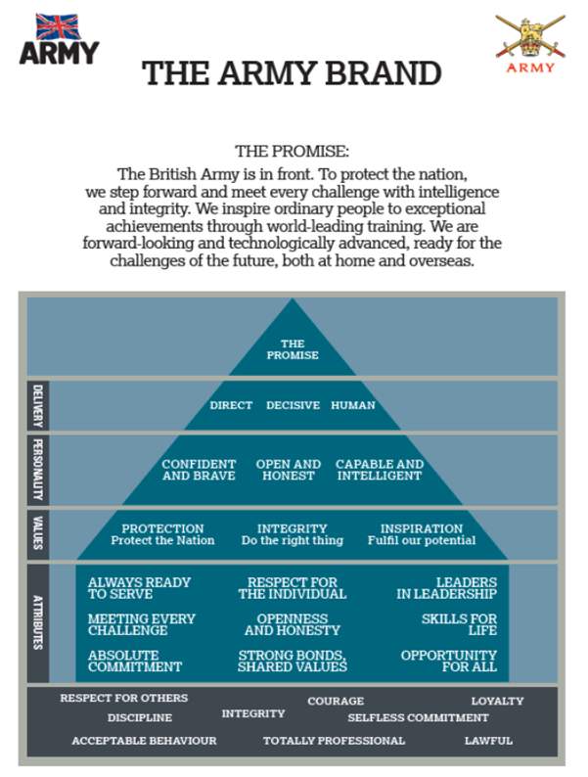
Stay in Touch with the ASCB:
Use the Army Sport Control Board Media Team to share all news items, results and photos, they can be sent via ASCB Media WhatsApp or Mobile 07539872007 and use #BritishArmySport
Ops Officer ASCB
Mil: 94222 7144 Civ: 01252 787144 opsbranch@ascb.uk.com

Media Officer ASCB
Mil: 94222 7057 Civ: 01252 787057 opsbranch@ascb.uk.com

Army Athlete Communications and Engagement Messages

Introduction. As an Army athlete you have an opportunity to pursue your sport as part of your military career and whilst having the benefit of a full salary – you should appreciate that this is a very special arrangement and one that puts you in an enviable position amongst your civilian counterparts. Whilst pursuing your sport you are to remember you are a soldier first. Wherever you are, you represent the Army and in some cases your NGB’s, Home Country (HC) and Great Britain and thus we expect you to conduct yourself accordingly.
Whether you appreciate it or not, your participation in Army Sport means that you represent the Army and thus you have a duty as a role model and mentor to both military and civilians alike. As your notoriety expands so will the effect and ‘reach’ of your social media presence. You may also generate media interest in terms of TV/radio and newspaper stories and requests for quotes and, in some circumstances, interviews. The purpose of this booklet is to offer some guidance should this occur, to highlight some of the potential ‘Trip Hazards’ to avoid and to provide you with some guidance on ‘what and what not’ to say, tweet and post, accepting that the Army expects to use sporting opportunities and its achieving athletes in particular, to promote Recruiting and Retention in the Army.
Lines to Take (LTT). Whenever the opportunity arises you should look to promote the opportunities available to you and your fellow soldiers and the support the Army has provided you with. You are asked to consider the following Key Messages and LTT throughout your time whilst being supported by the Army and funded by the Army Sport Control Board.
Key Messages – LTT - Sport in the Army:
- The Army as a Career: Wherever possible you should promote the Army as a career of choice for potential recruits who have a keen interest or ability in sporting activity. Understand what the Army is about by using the Army Brand information on the back of this leaflet.
- In the Army we have opportunity and time for sport: The value of sport in the Army is recognised and considered so important that it is core to our business and is a non-discretionary activity. Participation in sport enhances operational capability as it encourages fitness, commitment, team spirit and skill. It hones our competitive edge and develops leadership. Sport is a key part of the Army’ initiative to maximise talent and you, by competing on an Army Sport Programme, are a demonstration of that investment in individual talent.
- People are at the heart of everything we do: it is our people that make the difference.
- We play a lot of sport: Love sport? There’s no better place than to be in the Army:
From football to alpine skiing, you’ll get the chance to train with the very best coaches in world-class facilities in the UK and abroad.
- If you’re an absolute beginner, we’ll help you find your sporting passion and give you every opportunity to be the very best you can.
- Whatever your level of ability, a career in the Army will give you the chance to discover your sporting passions.
- The Army has sporting champions from a range of different disciplines. Find your place and passion with us.
- Sport is at the heart of Army life – it forms part of our DNA. Whether playing football with your mates or going on tour abroad to compete against teams from other countries.
- The Army is a great choice for people passionate about sport and are looking for a job that pays you to play.
- The ASCB supports athletes who are currently competing at a high level and where they are representing the Army, National and International Teams.

How You Are Supported:

- You should explain that your military career is carefully managed to ensure that it remains on track whilst you are continuing to progress in your chosen sport.

- You should thank those who support you: your unit and chain of command for providing the opportunity by allowing you the time to train and conduct your sport; the Army Sport Control Board for the support it provides across all sports and for the funding it provides through its Charitable Fund.

- You should explain that, as well as being paid, the Army is able to provide you with some funding to assist you in your sport.
- You should explain that the Army recognises and encourages participation in different sports – there is opportunity to find the sport that you enjoy and are good at and you are encouraged to do so.
- At every opportunity you should make reference to the level of support the Army has provided, including Army Sports Lottery Funding and the opportunity to conduct your chosen sport which maintaining a full career.

Practical Tips to consider If Approached by the Media
As you progress in your sport you may well find yourself in situations where you are required to give interviews or speak to the media. To help you:
- If at all possible, try not to be alone with a journalist always try to be with a member of your support team.
- Be helpful and polite and try to help them.
- Stay in lane and discuss only your situation, sport or event, linking your answers to the key messages highlighted in this booklet.
- Be positive and make the most of your opportunity.
- Advise HQ ASCB if you have conducted an interview and with whom, so that they can also share the interview across digital platforms.
- Where possible try to ensure you are wearing Army Branded training clothing or uniforms.
Social Media Advice and Guidelines:
- If you have not already done so you should link yourself with Claire Simpson (contact details below), the ASCB Social Media Manager, so that your feeds can be followed and where applicable posted to a far wider public audience.
- Complete Photo Permission forms with ASCB for your images to be utilised on Social Media.
- With success comes responsibility and whilst you have opinions you need to be mindful of what you say and about who or what. We suggest that you create (or keep) a private account to which you only accept and communicate with your close friends and family. This should be kept separate from your public account.
- As a member of the Army you will be expected to follow the Army’s Core Values. As a reminder, they are: Respect, loyalty, Integrity, Respect for Others, selfless commitment, Discipline.
- Whether you are on or off duty you must behave in a lawful appropriate and professional manner, wherever you are in the world. At all times, you are an ambassador for the Army.
- Let your personality shine through when you post. But don’t post negatively about others particularly competitors, organisations or brands. This is very important as despite your intent, comments can be misinterpreted.
- Before you press and send ensure you are content with what you are about to send. The likelihood is your post will not only be seen by a military audience, but a wider public community, you do not wish to be miss-quoted.
- Do not use foul or abusive language in your posts, tweets etc. Nor should you use symbols to replace letters and do not get embroiled in disputes with an audience.
- Don’t assume a deleted post will remain deleted as there is no way of knowing where it may have been reposted.
- Share your achievements, let people know what is next and how you get on. Post regularly, build a story, interact and build a following.
- Respond and answer questions posed to you as positive engagement is good, but never give out personal data or info.
- Be honest and correct any mistakes as soon as you can. Think about spelling and grammar. You will be visible to a younger audience and you should look to set a good example.
- Report anything that concerns you and use the ASCB Social Media Manager, Claire Simpson as your first POC if help is required.
- Consider the information you are going to post, use common sense about sensitive military issues and location of events. Generalise rather than specifics of venues and give a POC for further information.

