Ref: ATH/RBL5K/20

See Distribution: 06 Nov 20

## Army Virtual Race Series Race 5 – RBL Inter Corps 5K Road Race Nov 20

**General**

1. During these times of social distancing and the current lack of competition across the Services, Corps and Units, there is a gap that can be filled by virtual racing. Virtual racing allows individuals to compete against each other in a safe way that conforms with the government’s current social distancing guidelines. The next race in the series will be a Royal British Legion Inter Corps 5K. The Royal British Legion have been very strong supporters of Army Athletics for a number of years and their sponsorship allows Army Athletics to deliver the variety of events it currently does.

2. In these times where a number of charities are finding their usual routes to donations more difficult to access, it is only right that we now do our part in trying to advertise the RBL and the great job they do. This race is designed to allow everyone in the Army to take part as a member of your Corps with the Corps who has the highest number of entries receiving an prize that will be presented by the RBL at our annual awards dinner in 2021. There will be no entry fee for the race but everyone is encouraged to donate to the RBL to show our support (this donation is voluntary and no will be excluded from entering if they do not donate). To donate either scan the barcode below or text POPPY to the numbers shown below:

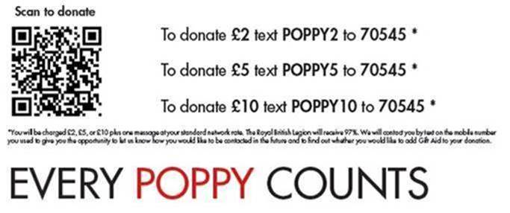

**Eligibility**

3. The RBL 5K is open to all serving members of the Regular Army (Men & Women), Reserve Forces and Army Veterans. There will be no separate Reserve forces competition all Reserve forces entries will be entered under the Inter Unit Championships in line with the one Army concept. The overall (individual only) results will also include retired personnel (veterans) who are to enter using the following code ARMYV Army Veterans.

|  |  |
| --- | --- |
|  |  |

4. There will be one race in which the following events will be contested:

1. Male Senior, Masters, U23 and Super Masters Individual.
2. Female Senior, Masters, U23 and Super Masters Individual.
3. Inter Corps Senior Male and Female Team.
4. Inter Corps U23 Male and Female Teams.
5. Inter Corps Masters Male and Female Teams (Male over 40, Female over 35).
6. Inter Corps Mixed Senior Masters Team (Male over 50, Female over 45).
7. Open age graded Team.

**Scoring**

5. Scoring for the individual competition will be top 1,2,3 in each category. Scoring for the team competitions will be the best accumulated places for each teams quickest 6 runners. Runners can count in all categories they are eligible for.

**Prizes**

6. Prizes will only be awarded for the overall Corps race series winners as follows within each category and for the best age graded individual overall results. Team prizes are subject to number of competing teams*:

**Individuals:**

1st Medal

2nd Medal

3rd Medal

**Team Championships:**

1st Team x 6 Medals

2nd Team x 6 Medals

*Minimum of 3 competing teams in a category.

Prizes will be awared at the Army Athletics Awards Dinner in 2021.

**Entries**

7. All entries are to be made via the Opentrack online system.

Initially personnel will need to sign up if they have not used Opentrack before or login if they already have a login.

All personnel should enter individually via the link. The race is accessible via the [Link](https://data.opentrack.run/en-gb/x/2020/GBR/ic_rbl_5k/) search button by entering Army Inter Corps and pressing the filter button. The following will be displayed:

[Inter Corps Royal British Legion 5k](https://data.opentrack.run/en-gb/x/2020/GBR/ic_rbl_5k/)

Click to access and then press enter to enter the competition. Add athlete and confirm you will then need to enter your Corps name or code (See Annex A) in the drop down menu. Once logged in individuals can upload their results which must include a Strava/Garmin connect embedded link.

Individuals must ensure that when they enter they select their Corps Code. All Corps team codes are shown at Annex A. Be aware if you group upload entries you will be responsible for entering the results for those individuals. The advice is to ensure that all participants register themselves and then they are responsible for entering their own results.

All those who are taking part in the AAA virtual series will be deemed on duty as long as they are abiding by the rules and any physical exemptions/limitations they may have.

**Rules**

8. The rules for the competition areas shown below and must be adhered to especially the social distancing:

The race is 5K and this must be evidenced by either Strava/Garmin connect embedded link which must be uploaded to open track. Each submission must have total activity time so that people cannot stop start their run.

* Social distancing guidelines MUST be adhered to (run solo, do not travel to your chosen route). Respect Government Guidelines.
* Efforts completed between 06 Nov and 30 Nov 20 will be counted.
* Entries must be submitted by 1200 hrs 30 Nov 20.
* Terrain
  + Running tracks are not to be used for this.
  + Start and finish within 500m of each other.
  + No treadmills.

**All athletes uploading Starva links are to ensure their accounts are accessible in order that their evlevation and distance can be checked. If they are not accessible the times will not be counted.**

**Results**

9. All timings must be uploaded by 1200 hrs on 30 Nov 20. The final results will be uploaded to Defence Connect.

**Security**

10. Be aware that when uploading your Strava/Garmin/Google/Apple to the Open Track site you will be uploading your start location. In order to ensure that service personnel are not giving details of their home location all runners are advised to begin their 1 mile away from their home address. Guidance would be to warm up without Strava/Garmin on and then begin the Strava at the beginning of your run and ensue that your run does not end at your home location.

Original Signed

J Killoran

Maj (Retd)

Secretary AAA

Distribution:

All Units

All Army Team Managers

Information:

President

Chairman

RBL

**Annex A to**

# **ATH/RBL5K/20**

# **Dated 06 Nov 20**

**Corps Codes of Opentrack Entry**

AAC Army Air Corps

AGC Adjutant General's Corp

AMS Army Medical Services

ARMYV Army Veterans

CAMUS Corps of Army Music

INFTY Infantry

INTEL Intelligence Corps

RAC Royal Armoured Corps

RACHD Royal Army Chaplins Corps

RAPTC Royal Army Physical Training Corps

RART Royal Artillery

REME Royal Electrical and Mechanical Engineers

RENG Royal Engineers

RLC Royal Logistics Corps

RSIG Royal Signals

SASC Small Arms School Corps

UOT UOTC/RMAS Cadets